Lab 2

Name: ___Keith Gable_________ Date: 16-Feb-2007_

Objective:
- Perform Normal, Differential and Incremental backups.

Instructions:
  - This lab must be worked on individually.
  - You may use the Systems in the Lab to complete this lab
  - Use Windows XP for the entire lab.
  - Please write down the requested information and capture screenshots where applicable.

- Normal Backup

- Create a folder (anywhere on your drive) and name it TEST. Within this folder create two folders named Backup and Restore.
- Using Windows Explorer, navigate to the folder /TEST/Backup. Create a file under this folder by right-clicking and selecting New -> Text Document. Double-click the file to open in Notepad. Enter the following line of message
Last week’s work.
- Name the file weekend.txt. Save and close the file.
- Now right click on the weekend.txt and select Properties -> General tab -> Advanced. Observe the state of the archive attribute bit, which is indicated by the status of the checkbox (checked or unchecked) for the item File is ready for archiving.
- Capture a screenshot and paste here.
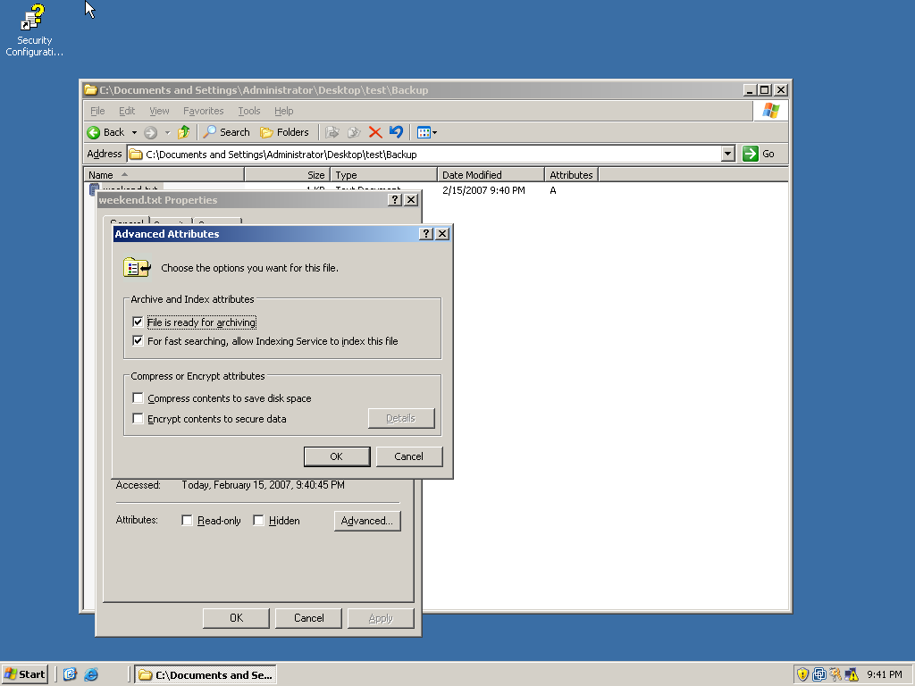
- Observe and record the
  - File modification time: 2/15/2007 9:40pm
  - State of the archive attribute bit for the file weekend.txt( your answer should be either checked or unchecked ) checked
  - State of the archive attribute bit for the Backup Folder unchecked

- Now select Start -> Programs -> Accessories -> System Tools -> Backup.
- Use the Backup Wizard and make the following selections:
  - Items to backup – /TEST/Backup
  - Place to save your backup - /TEST/Restore
  - Name of the backup file – weekend_normal_backup
  - Backup Type or Option – Normal
  - List the various backup options available in the Windows Backup utility:
Normal, Copy, Incremental, Differential, Daily

- Start the backup process.
- After performing the Normal backup observe and record the state of the archive attribute bit for the following under the TEST/Backup folder
  - file weekend.txt unchecked
  - folder Backup unchecked

- Differential Backup
- Create a new text document under /TEST/Backup and add the following line of message Monday’s work.
- Save it as Monday.txt and close the file.
- Observe and record the
  - File modification time: 2/15/2007 9:50pm
  - State of the archive attribute bit for the file weekend.txt still unchecked
  - State of the archive attribute bit for the file Monday.txt checked
  - State of the archive attribute bit for the Backup Folder still unchecked
- Use the Backup Wizard and make the following selections:
  - Items to backup – /TEST/Backup
  - Place to save your backup - /TEST/Restore
  - Name of the backup file – mon_diff_backup
  - Backup Type or Option – Differential
- Start the backup process.
- After performing the Differential backup observe and record the state of the archive attribute bit for the
  - file Monday.txt checked
  - folder Backup still unchecked
- Incremental Backup
- Use the Backup Wizard and make the following selections:
  - Items to backup – /TEST/Backup
  - Place to save your backup - /TEST/Restore
  - Name of the backup file – mon_inc_backup
  - Backup Type or Option – Incremental
- Start the backup process.
- After performing the Incremental backup observe and record the state of the archive attribute bit for the
  - file Monday.txt unchecked
  - folder Backup unchecked

- Definitions
Define the following: -
- Normal Backup:
  - Definition: A normal backup copies all selected files (regardless of the setting of the archive bit) and marks each file as having been backed up.
  - Effect on the state of the archive bit [write down whether or not it changes the archive bit (from checked to unchecked or vice versa ) after the backup]: cleared
- Differential Backup:
  - Definition: A differential backup copies files created or changed since the last normal backup.
  - Effect on the state of the archive bit(write down whether or not it changes the archive bit after the backup): archive attribute is not cleared
- Incremental Backup:
  - Definition:An incremental backup backs up only those files created or changed since the last normal or incremental backup.
  - Effect on the state of the archive bit(write down whether or not it changes the archive bit after the backup): cleared
- Copy Backup:
  - Definition: All selected files are backed up regardless of the setting of the archive bit.
  - Effect on the state of the archive bit(write down whether or not it changes the archive bit after the backup): not cleared
- Daily Backup:
  - Definition: Backs up files using the modification date on the file itself.
  - Effect on the state of the archive bit(write down whether or not it changes the archive bit after the backup): not cleared

